Faculty of Science, Engineering and Technology

n m e n t



Computer Systems

Week 6

# Overview

In this laboratory you will be working on your assignment

**Purpose:** To begin planning and get feedback/help on your assignment

**Task:**

**Time:** This lab is due by the start of your week 6 lab.

**Assessment:** This lab is worth 1% of your assessment for this unit, and only if demonstrat- ed to your lab demonstrator in the week it is due.

**Resources:** ■ Assignment Handout (download from Canvas)

* All previous resources

***Submission Details***

You must submit the following files to Canvas:

* A document containing all required work as described below.



Computer Systems Week 6 Laboratory

# Instructions

## Working on your assignment

1. Work on your assignment
2. What is the most challenging component of the assignment ? Be as specific as possible.

==> One of the most difficult part that I find in this assignment is the way how to arrange each section so that my circuit in such a nice way to understand and clear as much as possible. In addition to connect together and activate them properly as well

1. Discuss this answer, and your progress, with your lab demonstrator
2. Document your progress so far and plans

## Export a document of evidence of your progress to date, including images of notes/ screen shots and any other notes.

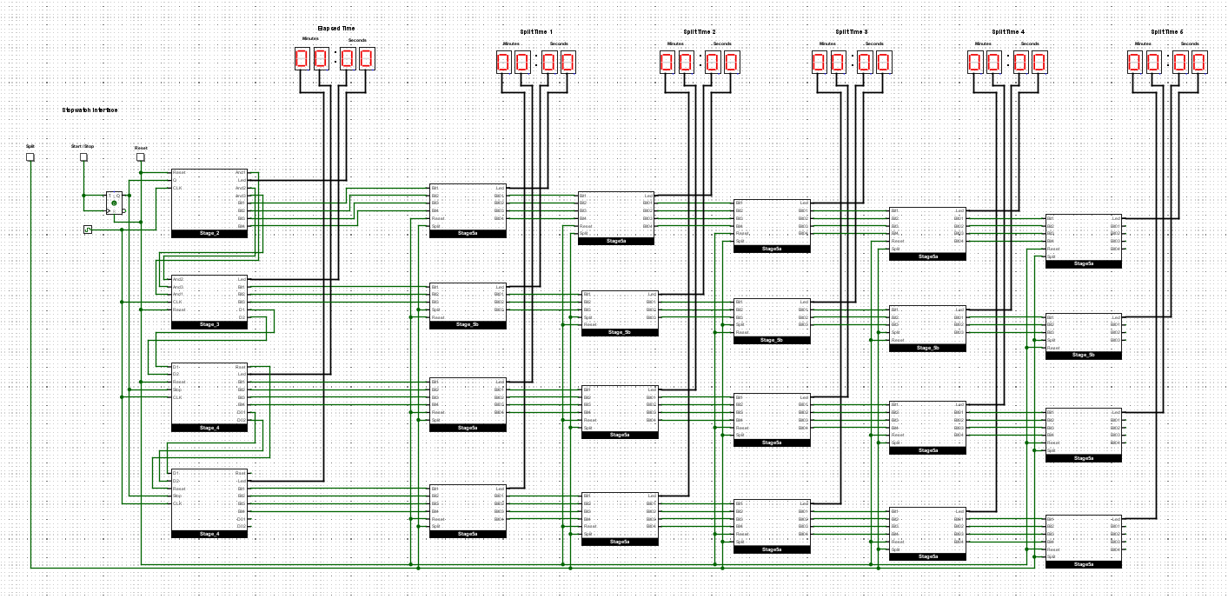

**When complete:**

* + Submit your answers (screen shots, etc) in a single document using **Canvas**
  + Show your lab demonstrator your working circuits in class (you must do this to get the 1%). Your lab demonstrator may request you to resubmit if issues exist.

Page 2 of 2